**DIRECTIONS FOR USING THIS PROGRAM:**

1. You need to install Java (the program is written in the programming language java, so your computer needs to be able to run it).

<https://www.oracle.com/java/technologies/downloads/#jdk19-windows>

Navigate to whatever system you are using, mac, windows, and download the executable. (For windows, you should just choose the “installer” option, not MSI or compressed, for mac, I am not sure since I do not use a mac, use your intuition, I think you need to figure out whether your processor is ARM or x64 –

<https://appletoolbox.com/intel-or-arm/#:~:text=You%20can%20do%20this%20by,serial%20number%20and%20macOS%20version>.

Maybe that link will help).

1. Next step is to download the program:

<https://drive.google.com/file/d/1b8k4ffHpmWUUUGq5SY7t4OrsD4nsV9Mp/view?usp=sharing>

After downloading the program, again I am not sure about mac, but for windows, the attachment should look like a coffee cup, like this:



If it does not, right click on the file, and click open with, choose another app, and then choose java and be sure to make it the default app to run these types of files. If you cannot figure it out text me.

1. Those were the hardest parts, now, launch the app, it should look like this:

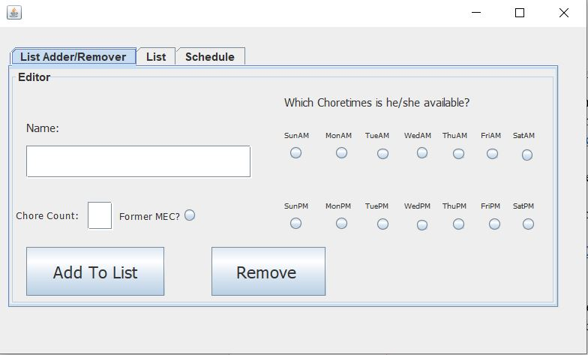

**Using the App:**

Its pretty simple, write their name, check the times when they are available, write the number of chores they want to do, and check whether they are former mec or not.

**Former MEC Check:**

The former MEC check is important because 1. It allows the schedule to be split up, allowing for more efficient organization, and 2. MEC members have priority to be on chore so new members will always have someone experienced with them.

**REMOVING PEOPLE:**

After adding a bunch of people, you will see that in the “List” tab, you can see them all with their available times. Want to remove someone? Easy, type in their name in the editor exactly how you wrote it (case sensitive) and click remove, the person should be removed.

**FINAL RESULT:**

After adding everyone you want to add, click organize and go to the schedule tab, here you should see the full schedule of people. If you want to add more people or remove and reorganize you can.

**IMPORTANT NOTES!!!!**

I have tried my best to debug this program and perfect it and its algorithm, but at the end of the day you are the one who knows how a schedule should or should not be organized, so I need you to try it a couple times and give me feedback. Check if people on chore were organized correctly, if they were put in the correct positions, etc. I have tested all this stuff extensively as I said, but consider this app in a BETA mode, I need you to tell me what to improve and what to change, so when the next semester comes, the program should be in tip top shape. Also, I may, as the semester progresses, test it out myself and may fix some things and send you a new version, but I will tell you if I want to do that.

Enjoy scheduling I guess idk.